1. SELECT * FROM `obat` ORDER BY harga DESC;  
   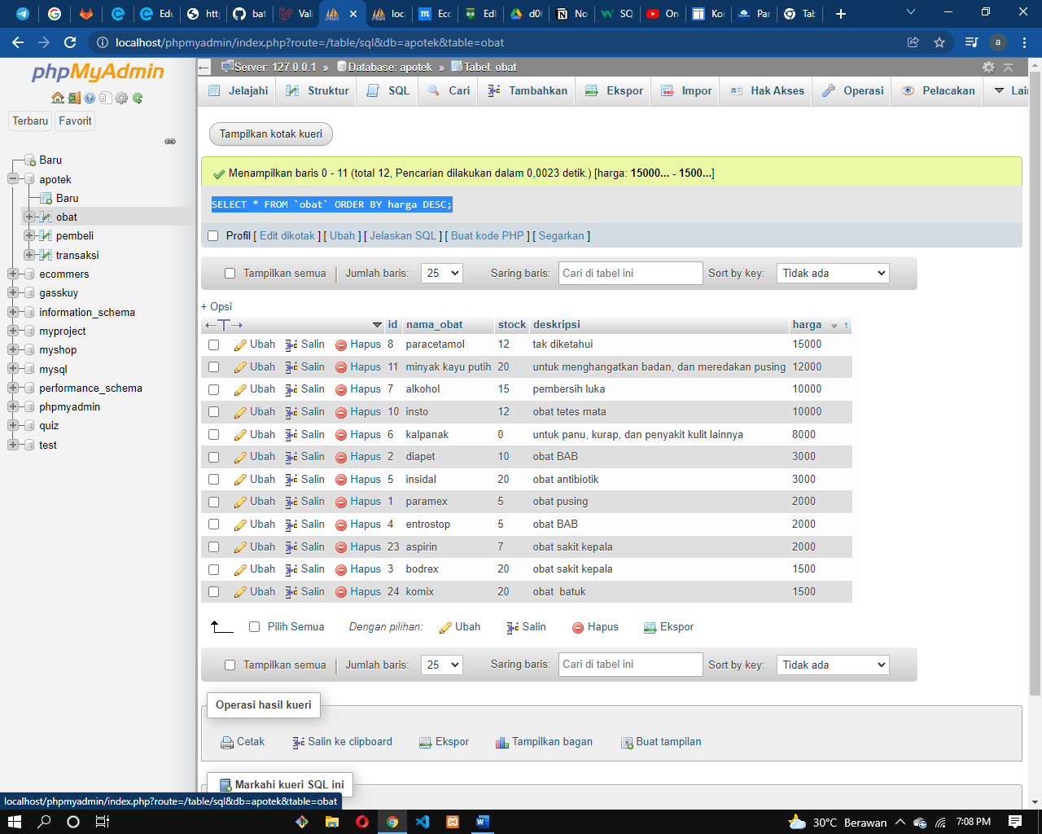
2. SELECT * FROM `obat` ORDER BY nama_obat ASC;  
   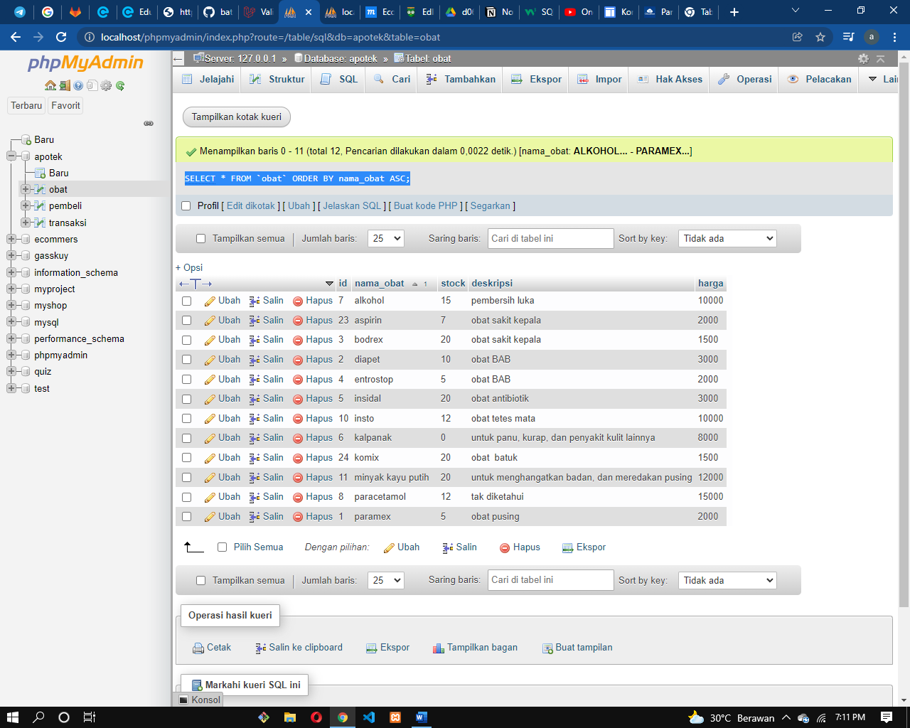
3. SELECT * FROM `pembeli` WHERE alamat LIKE '%jakarta%';  
   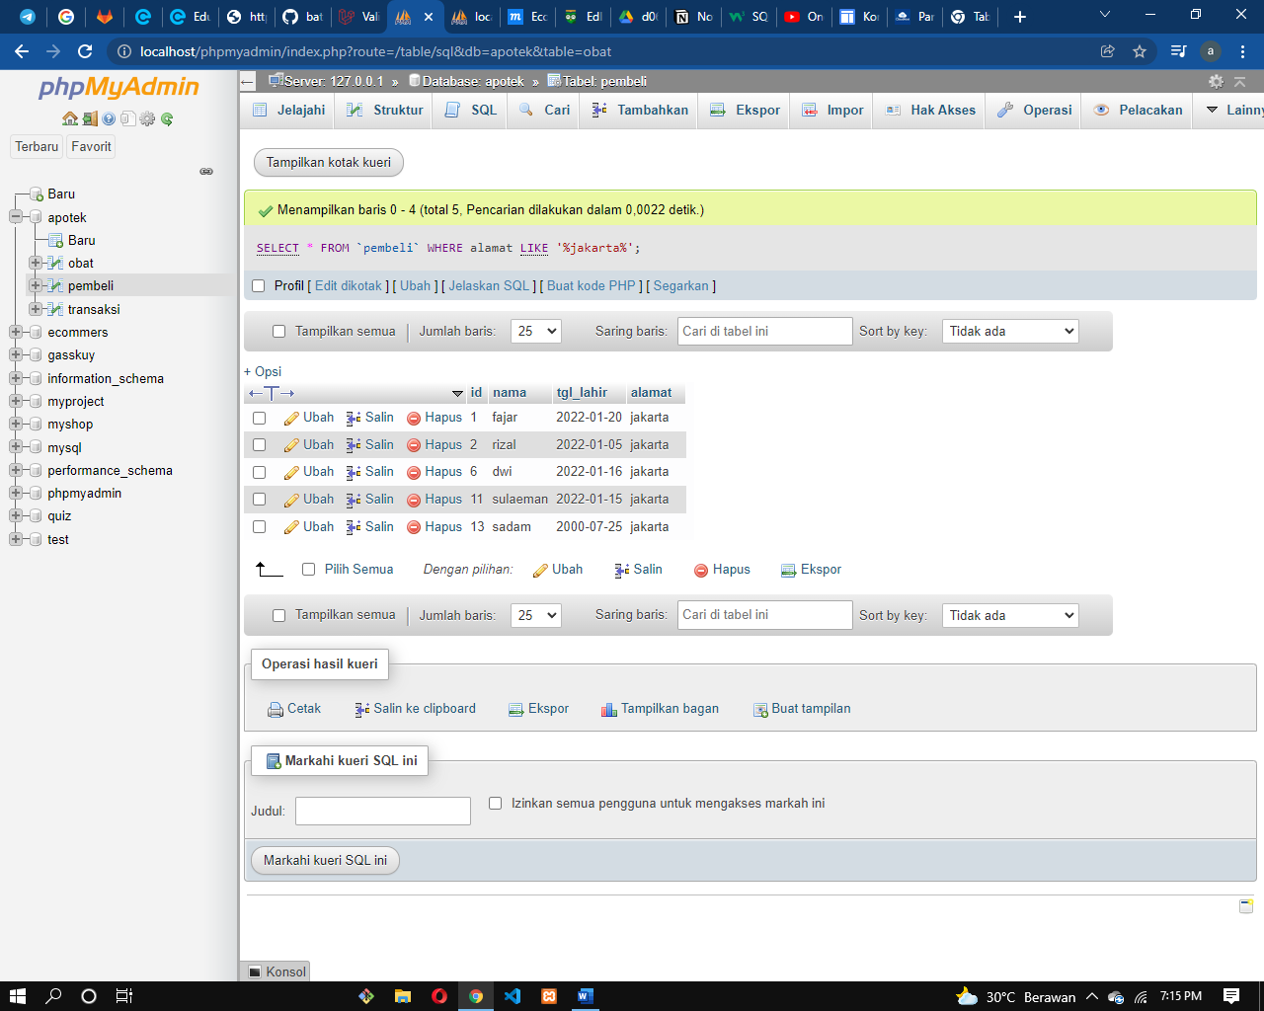
4. SELECT * FROM `obat` WHERE deskripsi LIKE '%obat%';  
   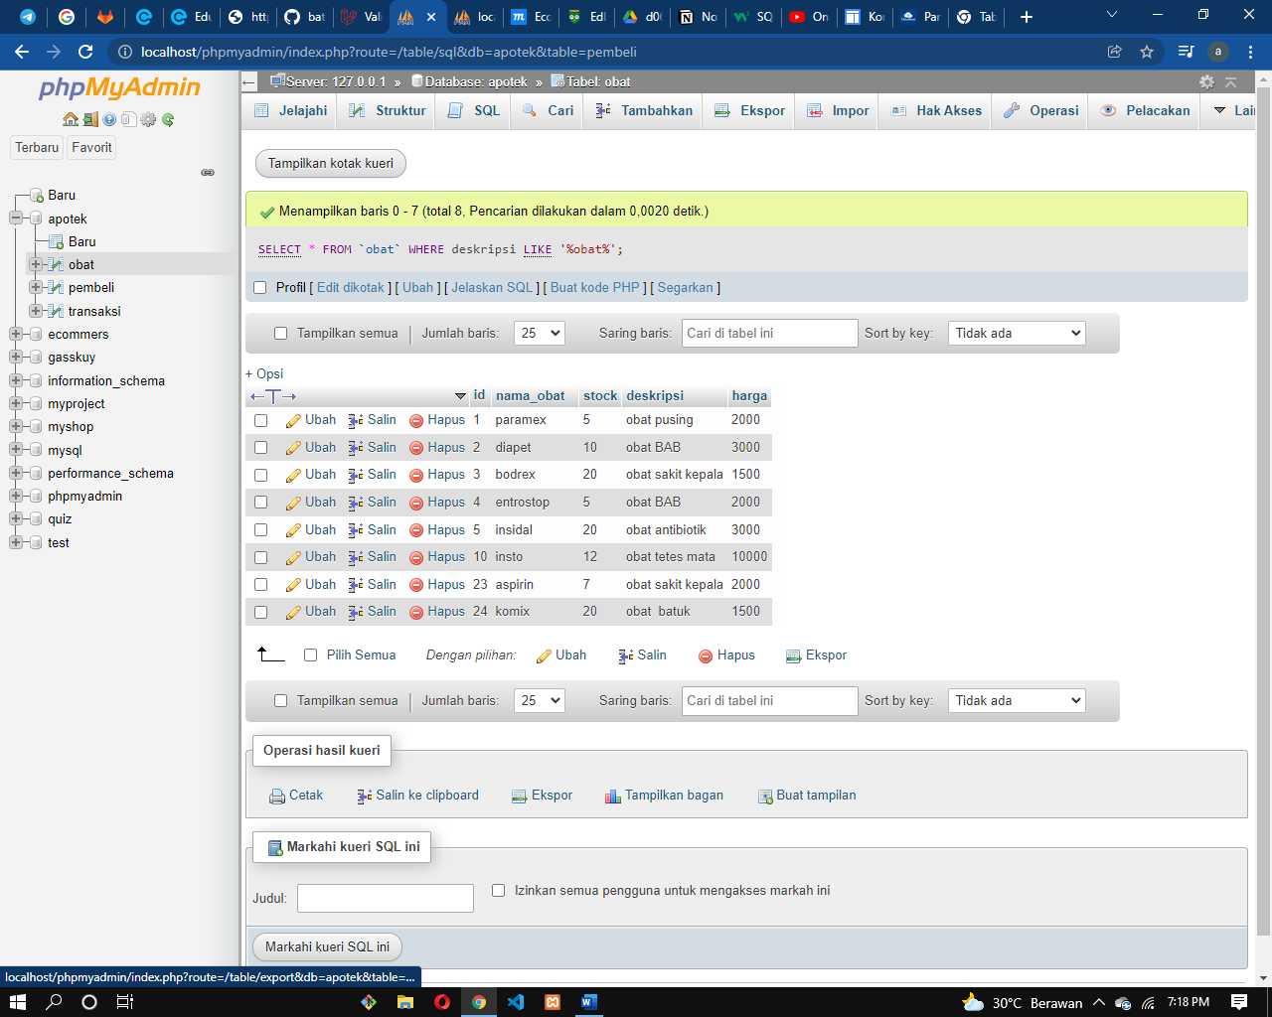
5. SELECT obat_id, SUM(jumlah) AS total FROM `transaksi` GROUP by obat_id;  
   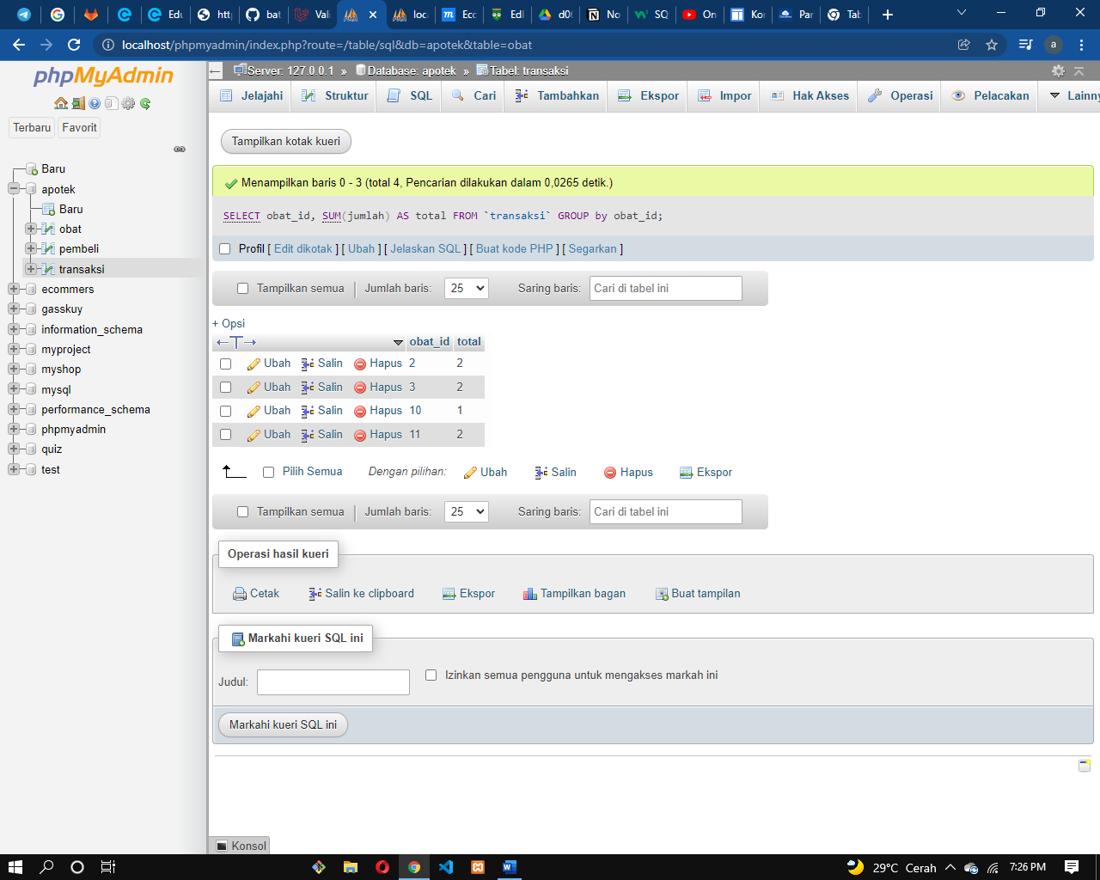
6. SELECT pembeli_id, SUM(jumlah) AS total FROM `transaksi` GROUP by pembeli_id;  
   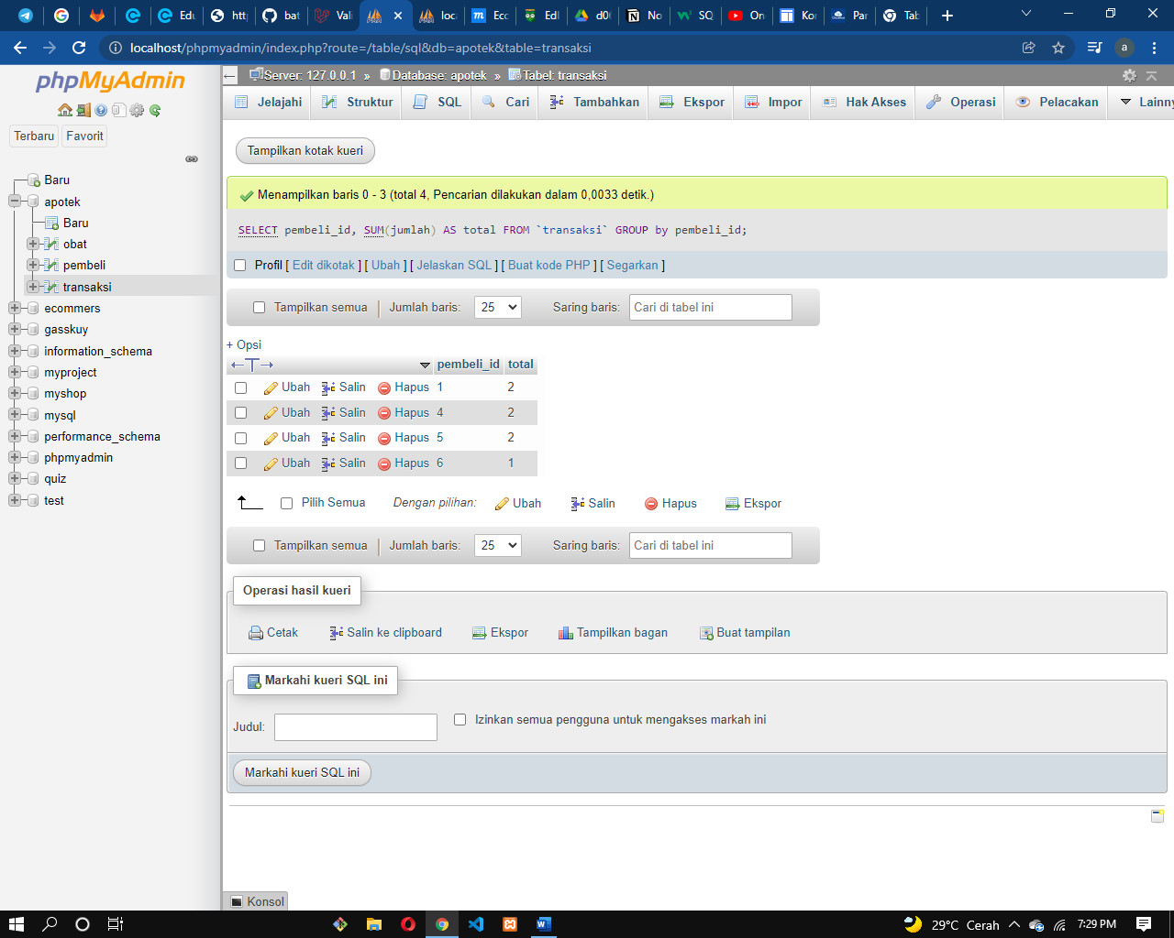
7. SELECT harga, SUM(stock) AS total FROM `obat` GROUP by harga>=2000;  
   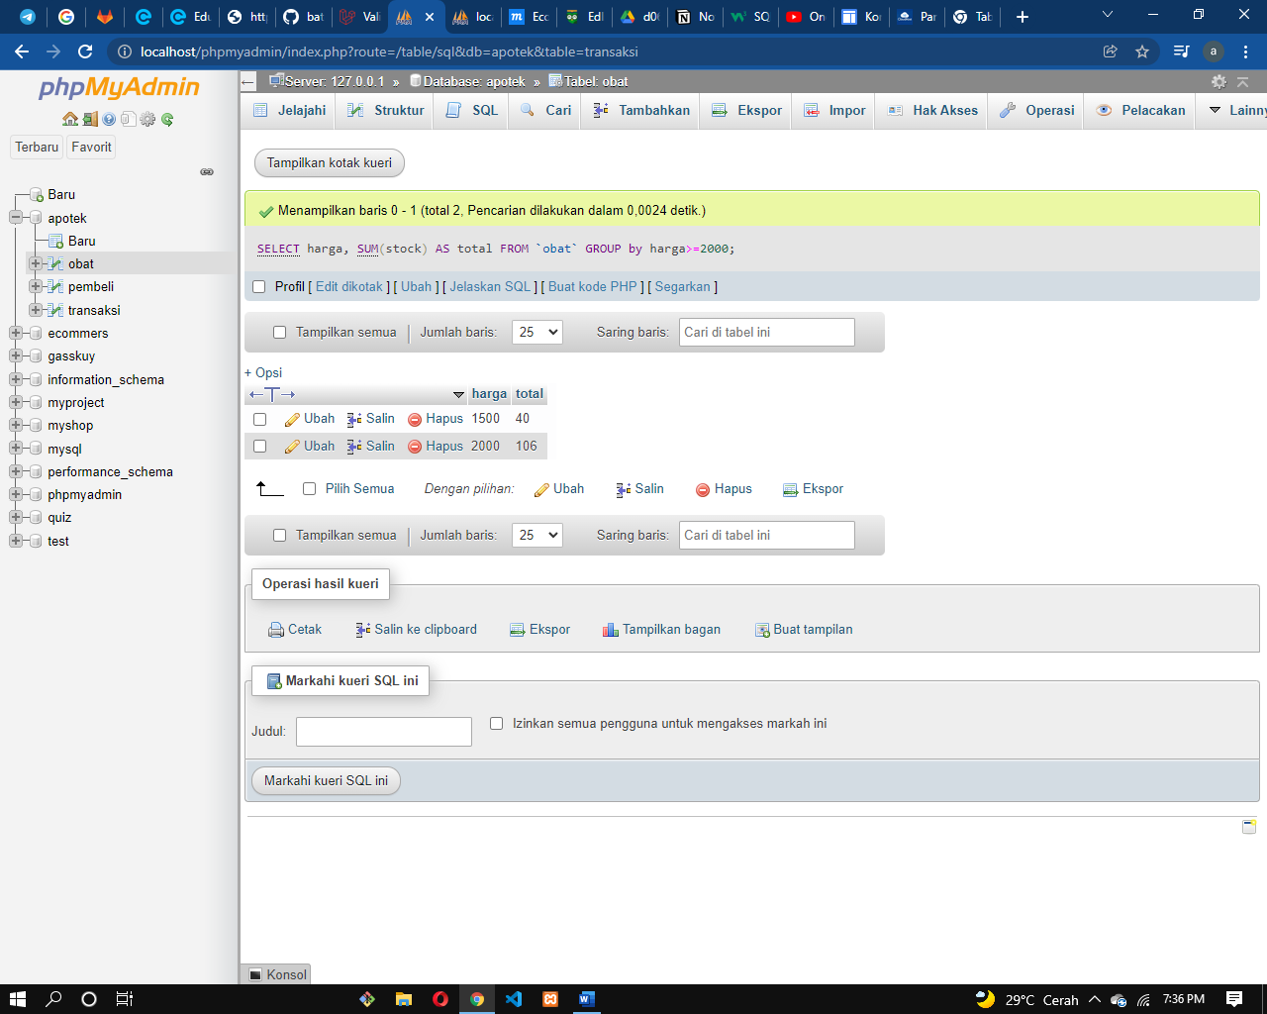
8. SELECT alamat , COUNT(id) AS total FROM `pembeli` GROUP BY alamat ORDER by COUNT(id) DESC;  
   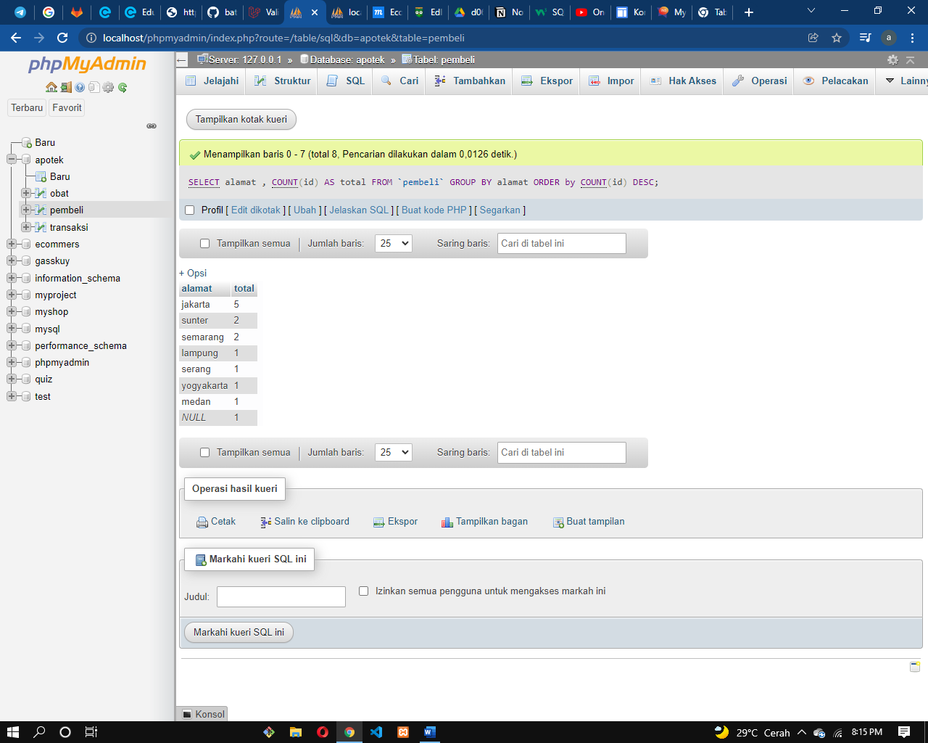
9. SELECT harga , COUNT(id) AS total FROM `obat` GROUP BY harga ORDER by COUNT(id) DESC;  
   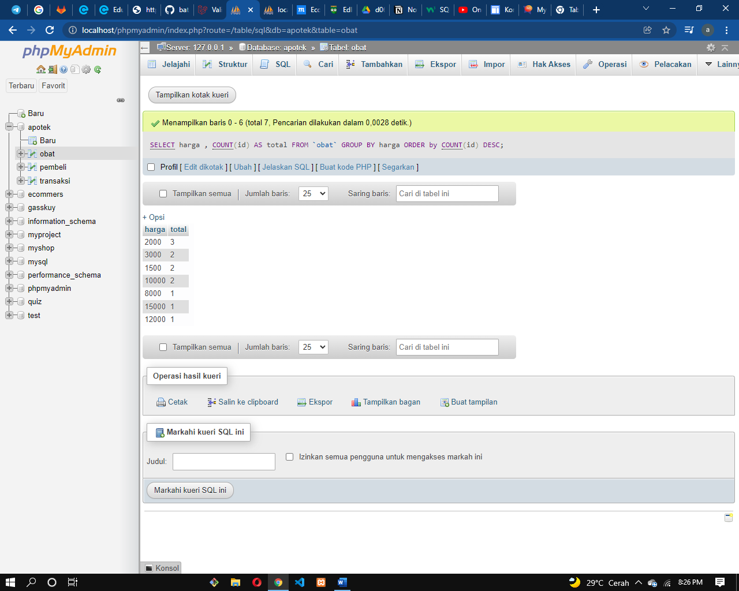
10. SELECT harga , COUNT(id) AS total FROM `obat` WHERE harga<10000 GROUP BY harga ORDER by COUNT(id) DESC;  
    